**Lab 1: Understanding ORM with a Retail Inventory System**

**1)create a .NET Console App:**

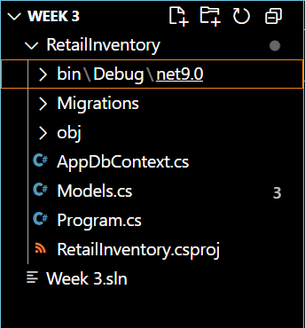

**2)Install EF Core Packages:**





**Lab 2: Setting Up the Database Context for a Retail Store**

**1)Create Models:**

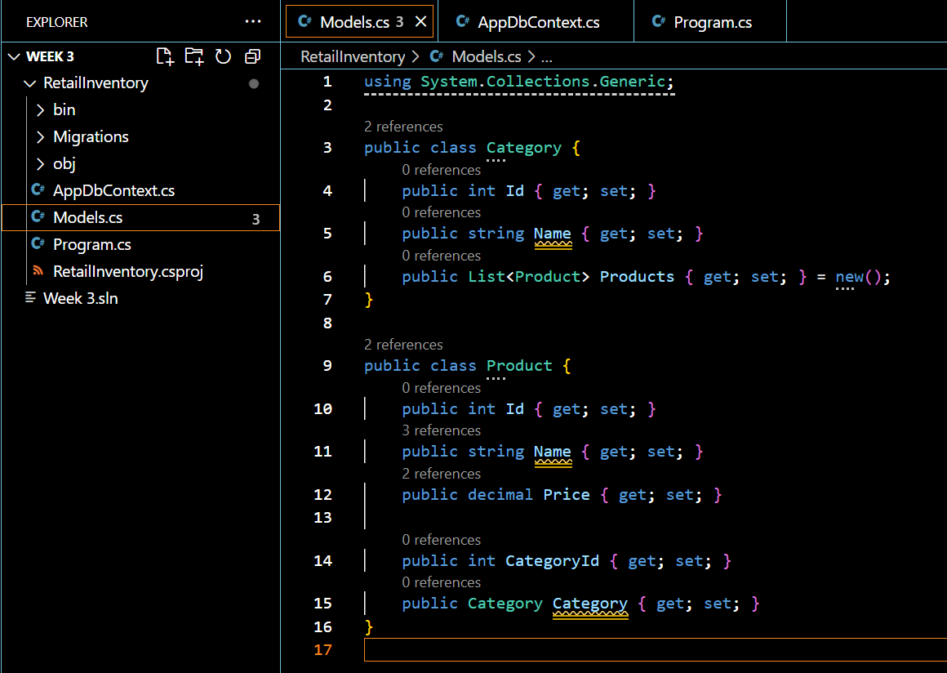

**2)Create AppDbContext:**

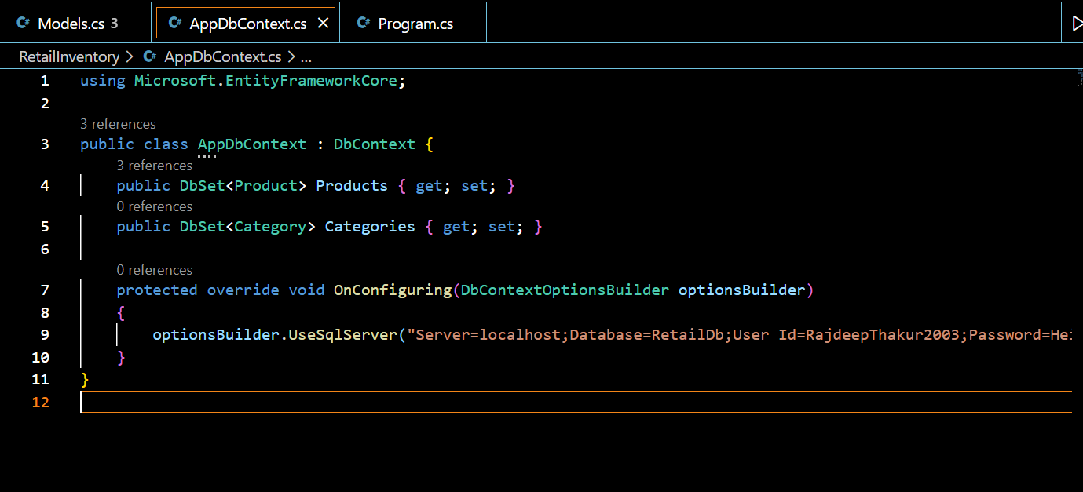

**Lab 3: Using EF Core CLI to Create and Apply Migrations**

**1)Create Initial Migration:**



**2)Apply Migration to Create Database:**

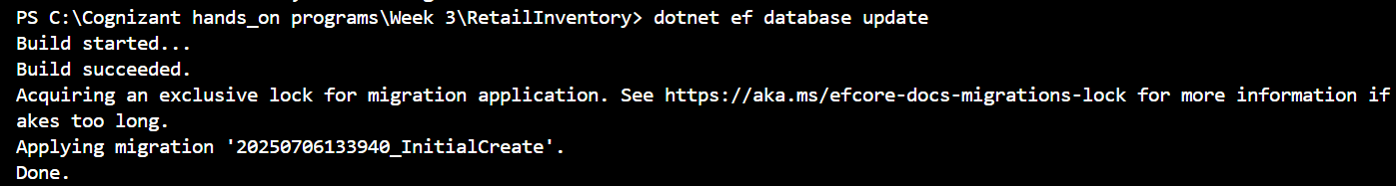

**Lab 4: Inserting Initial Data into the Database**

**1)Insert Data in Program.cs:**

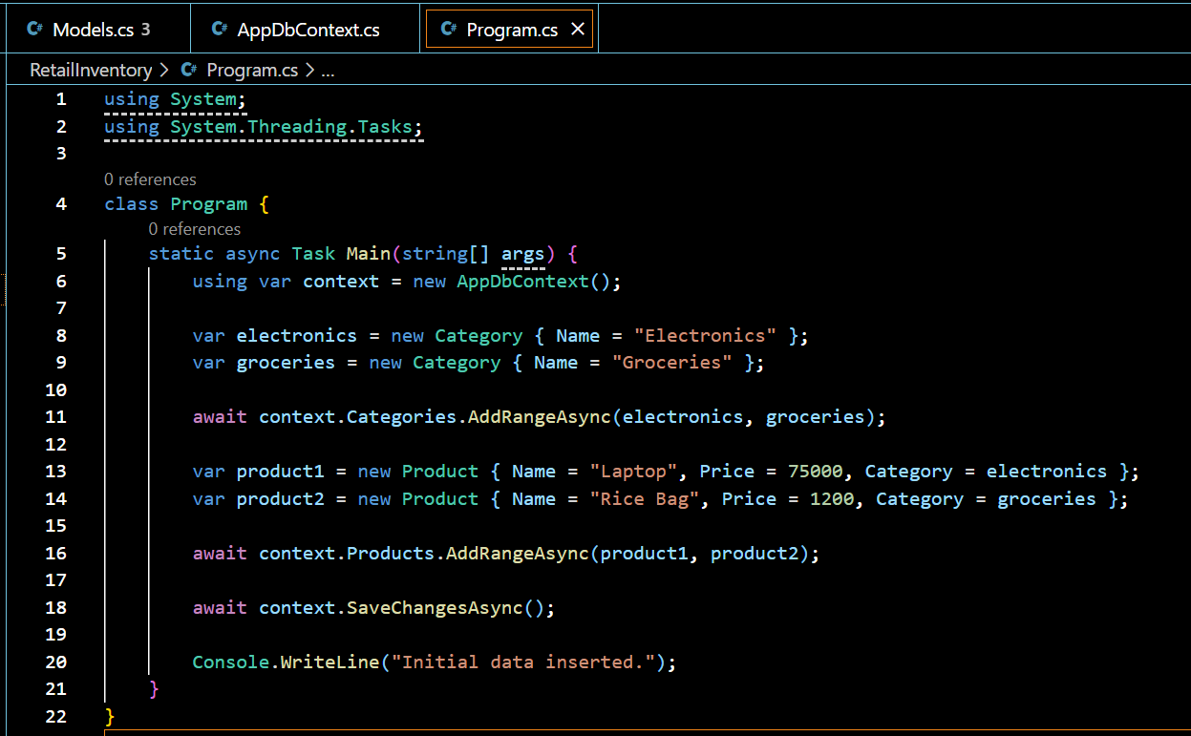

**2)Run the App**

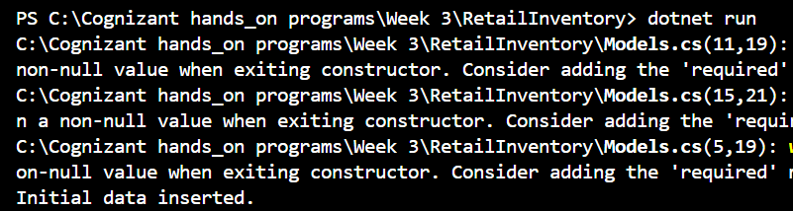

**Lab 5: Retrieving Data from the Database**

**1)Program.cs**

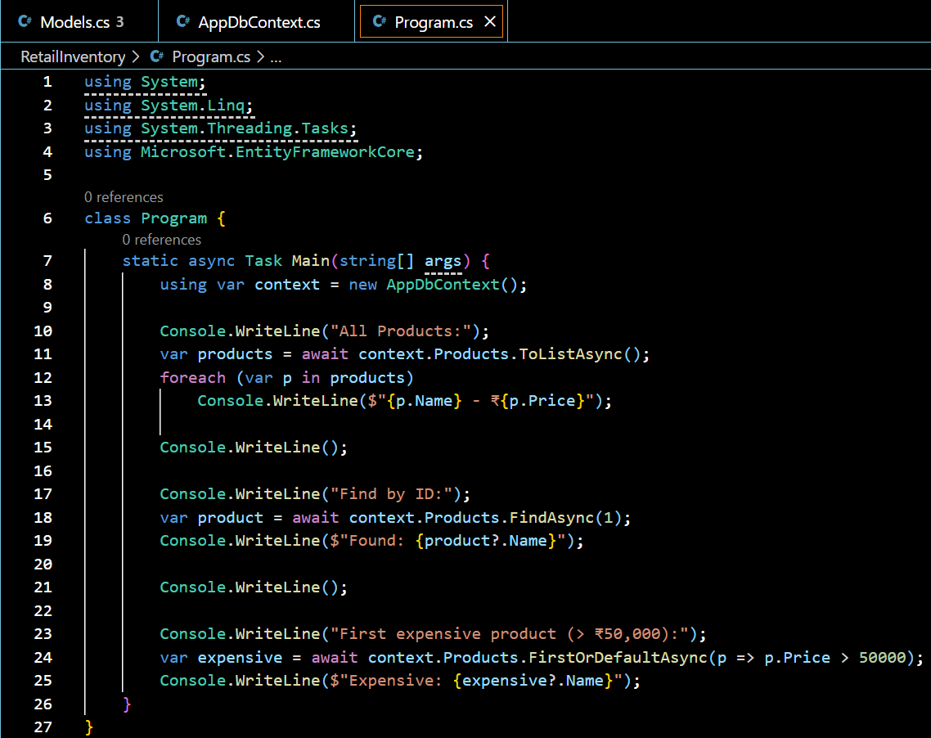

**2)Output:**

